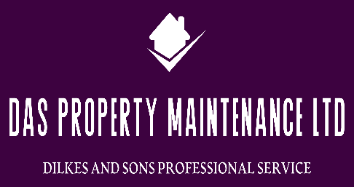***Dilkes and Sons property maintenance ltd***

**VAT Number: 451 7296 81**

**Company number: 14654653**

**Public liability: MMAC/ B6611647048696**

**Waste license: CBDU491060 environment agency**